**PGDB : User Guide**

ADMIN MODULE

* **USER CREATION [Main Menu 🡪 Users]**
  + Click on the Add button  to create a new user.
  + All fields are compulsory. Make sure to insert a valid email address as re-set password instructions will be sent to this email. **[user create – 1.2]**
  + If the new user is an administrator select YES for Admin user field.
  + After saving the record it will get added to the user list. **[user view – 1.1]**
  + The mail icon indicates users who have not yet re-set their passwords.
  + Click on it and you will see the mail content addressed to each user and you can directly click on Send Mail button to send / resend the mail. **[mail content – 1.3]**
  + Edit/ Delete options   allow you to make amendments to user details or remove user from the system respectively.

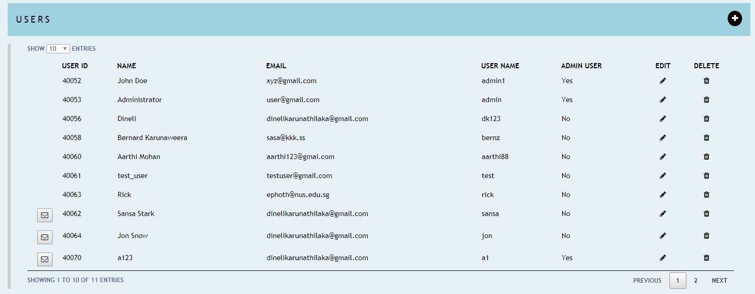 **[user view - 1.1]**

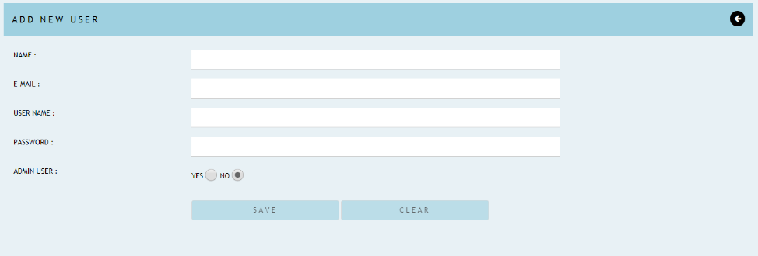 **[user create - 1.2]**

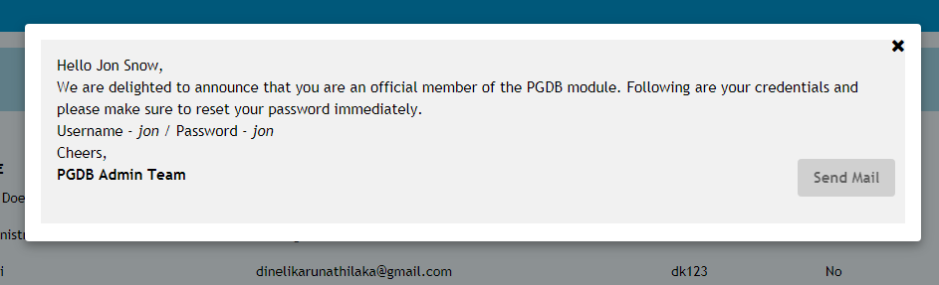

**[mail content – 1.3]**

USER MODULE [All of these features are available in the Admin module as well]

* **RESET PASSWORD [Main Menu 🡪 Reset Password]**
* Once the user receives the re-set password mail they can login to the system and access this page.
* Insert the password given in the email to the Old Password field and proceed with creating the new password. **[password reset – 1.4]**
* For existing users, insert your old password and proceed with creating the new password.

** Note : If you want to access 2 user accounts at once remember to use FireFox/ Safari. Chrome do not support this unless you use the incognito window. Use 2 separate browser windows to login to the 2 accounts.

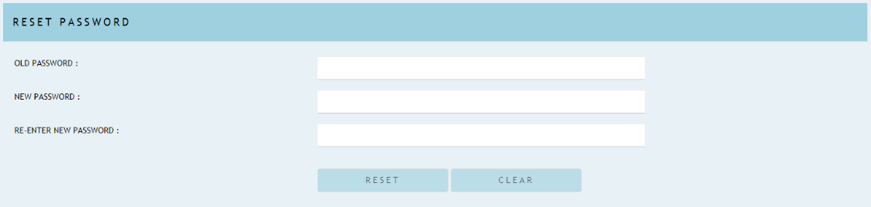

**[password reset – 1.4]**

* **PROJECTS [Main Menu 🡪 Projects]**
* This consists of 2 categories.

1. Your Projects : Projects created by you. **[your projects view – 1.5]**
2. Shared Projects : Projects shared with you by other users. **[shared projects view – 1.7]**
   * Click on the Add button to create a new project. **[project create – 1.6]**

* Use edit/ delete options to make amendments to the project or remove it from the system.
* When a project is added, a record will get inserted to *projects* and *user_projects* tables.

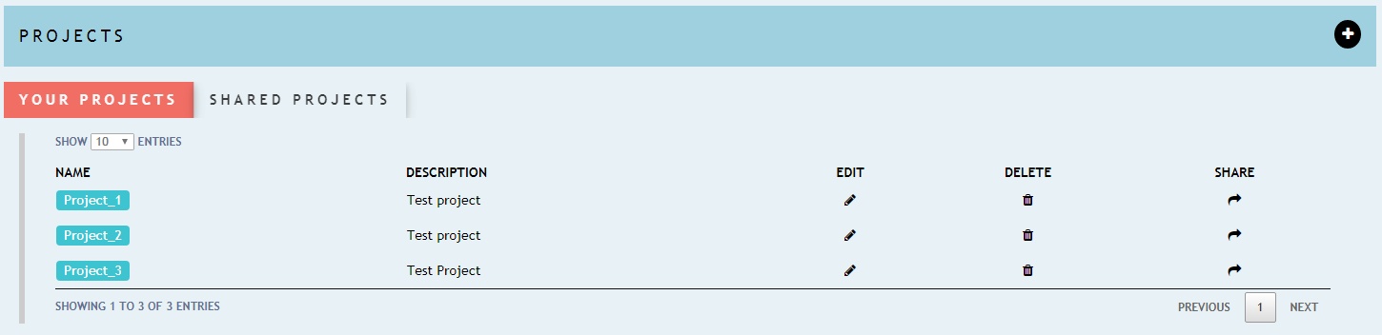

**[your projects view – 1.5]**

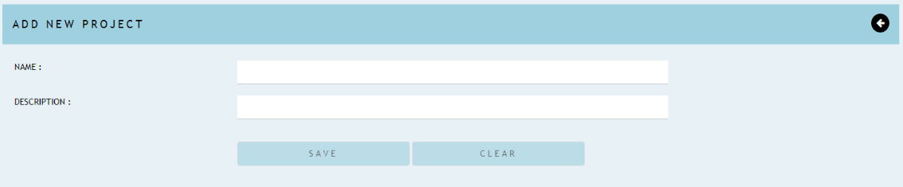

**[project create – 1.6]**

* **SHARING A PROJECT**
* Click on the icon to get started. **[your projects view – 1.5]**
* The left section of the page will display all the system users whom you can share your project with. A record will get inserted to the *shared_user_projects* table when you share the project with a new user. **[share project – 1.8]**
* The right section of the page will list down the users whom you have already shared the project with.
* The icon can be used to remove the user from project sharing. **[share project – 1.8]**

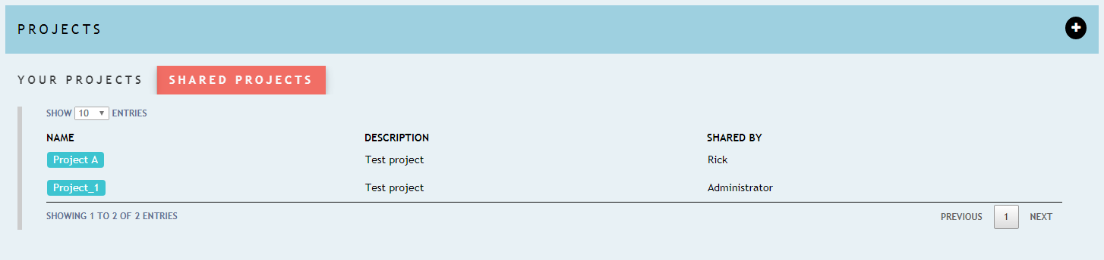

**[shared projects view – 1.7]**

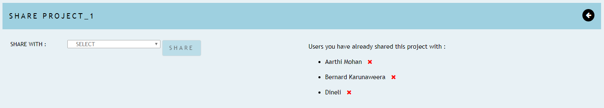

**[share project – 1.8]**

* **SAMPLES [Main Menu 🡪 Projects 🡪 Samples]**
* Click on the project name to access the samples view. **[samples view – 1.9]**
  + Click on the Add button to create a new sample. Sample name should be always unique.

**[sample create – 2.0]**

* Use edit/ delete options to make amendments to the sample or remove it from the system.
* When a sample is added, a record will get inserted to *samples* and *project_samples* tables.

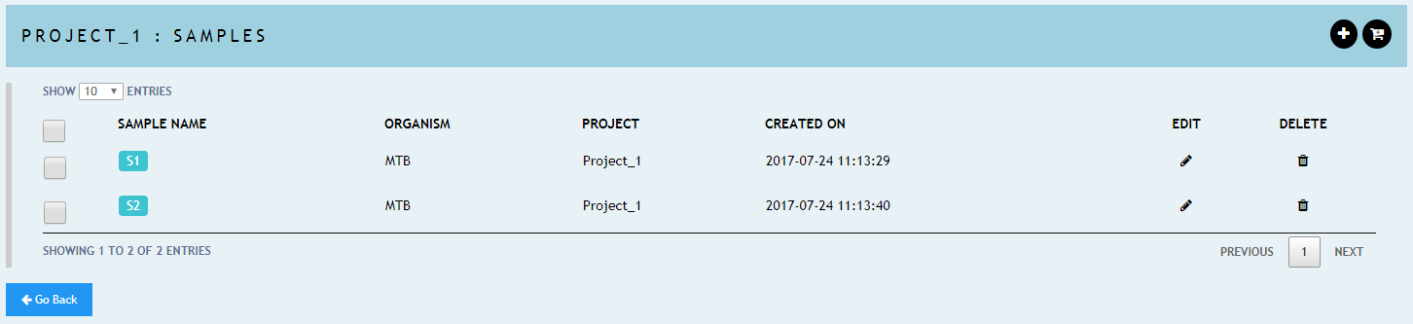

**[samples view – 1.9]**

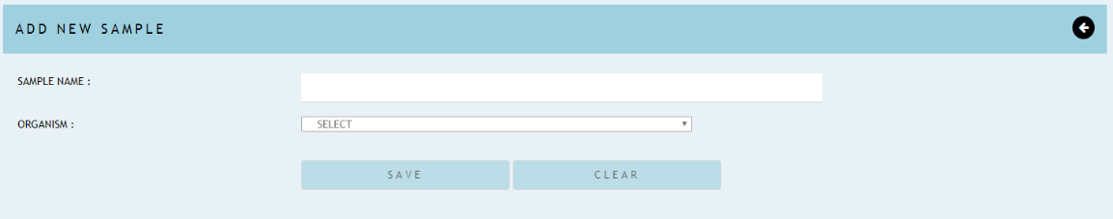

**[sample create – 2.0]**

* **SEQUENCE FILES [Main Menu 🡪 Projects 🡪 Samples 🡪 Sequence Files]**
* Click on the sample name to access the sequence files view. **[seq. files view – 2.1]**
* Click on to upload fastq files.
* Validations: Only 2 files can be uploaded per sample and it should be paired-end files.
* When a file gets uploaded, a new record gets inserted to the *sequence_files* and *sample_sequence_files* tables.

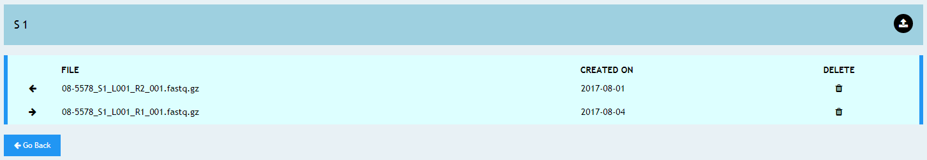

**[seq. files view – 2.1]**

* **CART**
* Samples with fastq files can be added to the cart using  button. **[samples view – 1.9]**.You can add samples from your own/shared projects to the cart.
* The new addition will indicate from the cart size  and cart items can be view by clicking the same icon. **[menu bar view – 2.2]**
* Cart items can be deleted individually by clicking on the cross mark in front of each item or can be deleted all at once by clicking the clear button on the top left corner. **[cart view – 2.3]**
* Each new cart item will get recorded in *jobs_cart* table.



**[menu bar view – 2.2]**

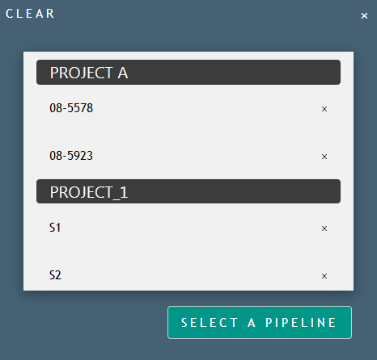

**[cart view – 2.3]**

* **PIPELINE EXECUTION**
* Once the cart items are finalized, click on the ‘Select A Pipeline’ button 🡪 Chose the pipeline you want to execute (currently there’s only 1 pipeline available in the system) 🡪 Set the parameters according to your preference 🡪 Execute Pipeline. **[pipeline execution – 2.4]**
* For each new pipeline execution, a record will get inserted to the *pipeline_jobs* table.



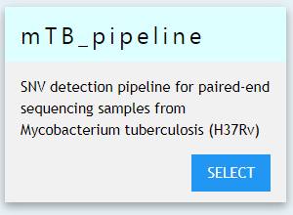

**[pipeline execution – 2.4]**

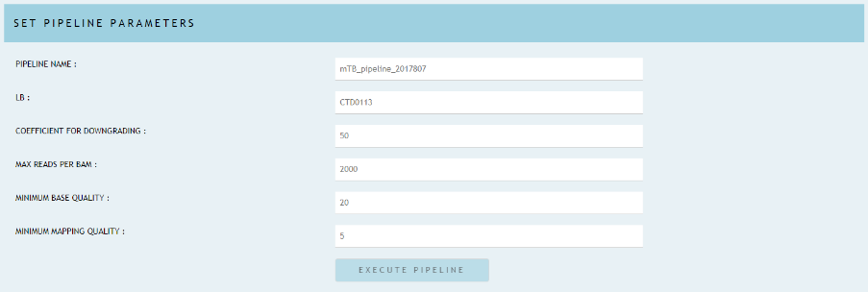

- **ANALYSIS**

* This view will display the progress of the executed pipelines. **[analyses view – 2.5]**
* During the execution process, you can refresh the page time to time using button, and the status field gets updated depending on the progress of the pipeline.
* If the pipeline is successful you will see a download button where you can download the output.
* You can remove the records using the delete button and all the input files/folders will get remove from the physical path as well as from the DB and a record will get inserted to the *pipeline_jobs_history* table in order keep track of the deleted record.

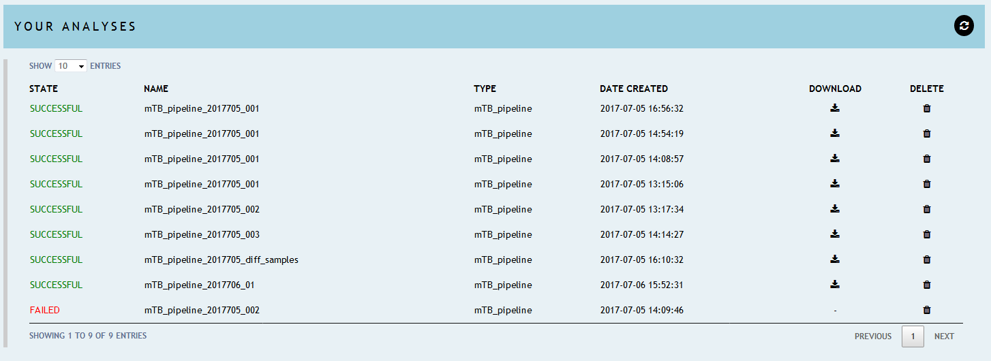

**[analyses view – 2.5]**

* **ADDED FEATURES**

1. 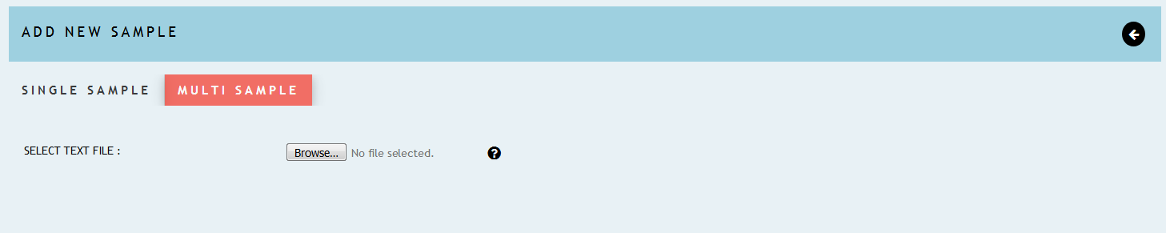Multiple Sample Creation [Main Menu 🡪 Projects 🡪 Samples 🡪  🡪 Select Multi Sample Tab]

* Upload the text file according to the instructions provided in the help icon.
* The new sample names shouldn’t exists in the system for that particular user.

1. 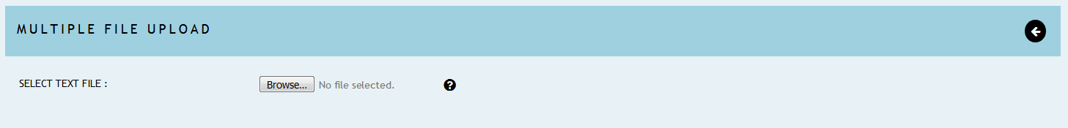Bulk File Upload [Main Menu 🡪 Projects 🡪 Samples 🡪  ]

* Upload the text file according to the instructions provided in help icon.
* If it’s successful you can proceed and upload the relevant fastq files.

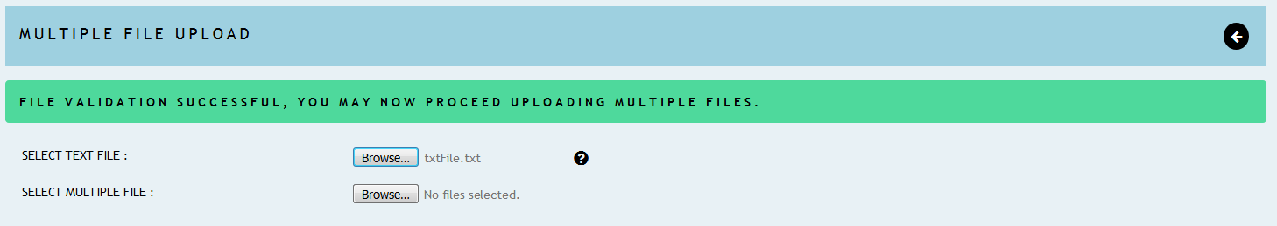

1. Bulk File Download [Main Menu 🡪 Projects 🡪 Samples 🡪  ]

* Select the samples you need to download and click on the download button.
* To download all the samples you can simply click on the download button provided on the Projects page.
* Make sure all the download files are unique [no duplicate files] if not, this function will not work properly.

**ICON GALLERY**

 🡪 Main Menu

 🡪 Cart

 🡪 Logged in user

 🡪 Logout

 🡪 Add new record

 🡪 Edit record

 🡪 Delete record

 🡪 Share project

 🡪 Download results

 🡪 Add samples to the cart

 🡪Go back

 🡪 Upload files

 🡪 Refresh page

🡪 View mail content

 🡪 File download

 🡪 Bulk file upload